II BTech ECE - I Sem R18 Digital System Design Laboratory

7. Realization of Boolean Expressions using Gates

Aim: To simplify the given expression and realize using basic gates

Apparatus:

- IC 7408 and IC 7432

- IC Trainer Kit

- Patch Cords

Theory:

Karnaugh maps are the most extensively used tool for simplification of Boolean functions. In an n-variable K-map there are 2ⁿ cells. Each cell corresponds to one of the combinations of n variable, since there are 2ⁿ combinations of n variables.

A Boolean function can be represented by a Karnaugh map in which each cell corresponds to a minterm. The cells are arranged in such a way that any two immediately adjacent cells correspond to two minterms of distance 1.

Simplification of expression:- Y=(A,B,C,D)= Σ(5,7,9,11,13,15)

Write the expression in Canonical form Y=A’BC’D+A’BCD+AB’C’D+AB’CD+ABC’D+ABCD Y =A’BD (C+C’)+AB’D(C+C’)+ABD(C+C’)

- =A’BD+AB’D+ABD Y =BD(A+A’)+AB’D Y=BD+AB’D Y=D(B+AB’)

Y=D(A+B) Y =AD+BD Simplification using K-map:

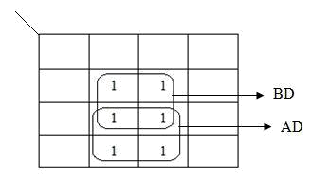

CD
AB

After simplifying using K-Map method, we get

Y=AD+BD

Page 1 of 34

II BTech ECE - I Sem R18 Digital System Design Laboratory

Pin diagram:

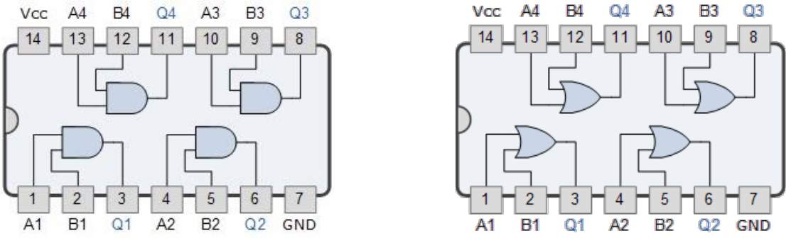

7408 7432

Circuit diagram:
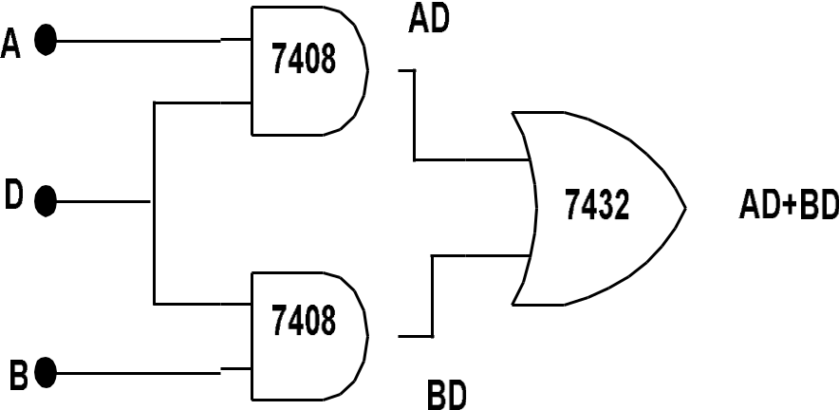

Procedure:

- Simplify the given Boolean expression using 4 Variable K-Map to minimize the number of literals in the given expression.

- Design Logic circuit using Basic gates.

- Check the components for their working. Insert the appropriate IC into the IC base.

- Make connections as shown in the circuit diagram.

- Provide the input data via the input switches and observe the output on output LEDs

- Verify the Truth Table.

Page 2 of 34

II BTech ECE - I Sem R18 Digital System Design Laboratory

Truth table:

 |  | Inputs |  |  | Output
A | B |  | C | D | Y
0 | 0 |  | 0 | 0 | 0
0 | 0 |  | 0 | 1 | 0
0 | 0 |  | 1 | 0 | 0
0 | 0 |  | 1 | 1 | 0
0 | 1 |  | 0 | 0 | 0
0 | 1 |  | 0 | 1 | 1
0 | 1 |  | 1 | 0 | 0
0 | 1 |  | 1 | 1 | 1
1 | 0 |  | 0 | 0 | 0
1 | 0 |  | 0 | 1 | 1
1 | 0 |  | 1 | 0 | 0
1 | 0 |  | 1 | 1 | 1
1 | 1 |  | 0 | 0 | 0
1 | 1 |  | 0 | 1 | 1
1 | 1 |  | 1 | 0 | 0
1 | 1 |  | 1 | 1 | 1

Result: The Boolean function using basic gates are simplified and verified.

Viva questions:

- What are the different methods to obtain minimal expression?

- What is a Min term and Max term?

- State the difference between SOP and POS.

- What is meant by canonical representation?

- What is K-map? Why is it used?

Page 3 of 34

II BTech ECE - I Sem R18 Digital System Design Laboratory

8. Realization of Boolean Expressions using universal Gates

Aim: To simplify the given expression and realize using universal gates

Apparatus:

1.IC 7400

2.Trainer Kit

3. Patch Cords

Theory:

Karnaugh maps are the most extensively used tool for simplification of Boolean functions. In an n-variable K-map there are 2ⁿ cells. Each cell corresponds to one of the combinations of n variable, since there are 2ⁿ combinations of n variables.

A Boolean function can be represented by a Karnaugh map in which each cell corresponds to a minterm. The cells are arranged in such a way that any two immediately adjacent cells correspond to two minterms of distance 1.

Simplification of expression: - Y=(A,B,C,D)= Σ(5,7,9,11,13,15)

Write the expression in Canonical form Y=A’BC’D+A’BCD+AB’C’D+AB’CD+ABC’D+ABCD Y =A’BD (C+C’)+AB’D(C+C’)+ABD(C+C’)

- =A’BD+AB’D+ABD Y =BD(A+A’)+AB’D Y=BD+AB’D Y=D(B+AB’)

Y=D(A+B) Y =AD+BD Simplification using K-map:

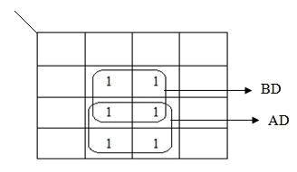

CD
AB

After simplifying using K-Map method, we get

Y=AD+BD

Page 4 of 34

II BTech ECE - I Sem R18 Digital System Design Laboratory

Pin diagram:

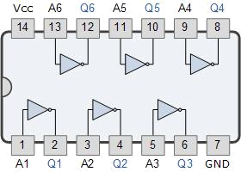

Circuit diagram:

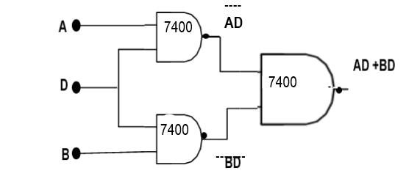

Procedure:

- Simplify the given Boolean expression using 4 Variable K-Map to minimize the number of literals in the given expression.

- Design Logic circuit using universal gates.

- Check the components for their working. Insert the appropriate IC into the IC base.

- Make connections as shown in the circuit diagram.

- Provide the input data via the input switches and observe the output on output LEDs

- Verify the Truth Table.

Page 5 of 34

II BTech ECE - I Sem R18 Digital System Design Laboratory

Truth table:

 |  | Inputs |  |  | Output
A | B |  | C | D | Y
0 | 0 |  | 0 | 0 | 0
0 | 0 |  | 0 | 1 | 0
0 | 0 |  | 1 | 0 | 0
0 | 0 |  | 1 | 1 | 0
0 | 1 |  | 0 | 0 | 0
0 | 1 |  | 0 | 1 | 1
0 | 1 |  | 1 | 0 | 0
0 | 1 |  | 1 | 1 | 1
1 | 0 |  | 0 | 0 | 0
1 | 0 |  | 0 | 1 | 1
1 | 0 |  | 1 | 0 | 0
1 | 0 |  | 1 | 1 | 1
1 | 1 |  | 0 | 0 | 0
1 | 1 |  | 0 | 1 | 1
1 | 1 |  | 1 | 0 | 0
1 | 1 |  | 1 | 1 | 1

Result: The Boolean function using universal gates is simplified and verified.

Viva questions:

- What are the different methods to obtain minimal expression?

- What is a Min term and Max term?

- State the difference between SOP and POS.

- What is meant by canonical representation?

- What is K-map? Why is it used?

Page 6 of 34

II BTech ECE - I Sem R18 Digital System Design Laboratory

9. Generation of clock using NAND / NOR gates

Aim: To design a clock using NAND Gate.

Apparatus:

- Nvis 6550A & IC CD 4011, 1k Resistance, 100E Resistance, 100uF/25V Electrolytic capacitor.

- Cathode Ray Oscilloscope

- Patch Cords

Theory:

A clock generator is a circuit that produces a timing signal (known as a clock signal and behaves as such) for use in synchronizing a circuit's operation. The signal can range from a simple symmetrical square wave to more complex arrangements. The basic parts that all clock generators share are a resonant circuit and an amplifier. Since all logic operations in a synchronous machine occur in synchronism with a clock, the system clock becomes the basic timing unit. The system clock must provide a periodic wave forms that can be used as a synchronous signal. The square waveform is a

typical clock waveform used in a digital system. The clock defines a basic timing interval during which logic operation must be performed. This basic timing interval is defined as a clock cycle time and is equal to one period of the clock waveform. Thus, all logic elements, flip-flops, gates, and so on must complete their transition in less than one clock cycle time. In this experiment to generating the clock we are using the NAND and NOR gates using these gates we are generating the clock signal.

Pin diagram:

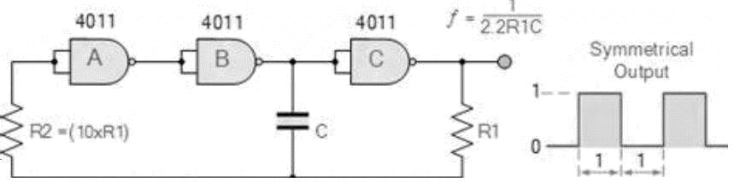

Page 7 of 34

II BTech ECE - I Sem R18 Digital System Design Laboratory

Circuit diagram:

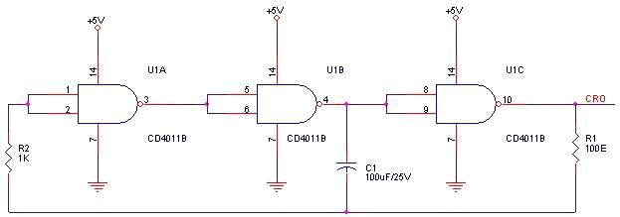

Procedure:

- Make the connection as per the above connection diagram.

- Switch On the power supply.

- Observe the output on the CRO.

- By changing the value of R1, R2 and C1 to change the Clock Output.
1
⁼ 2.2 1

Expected Wave forms:

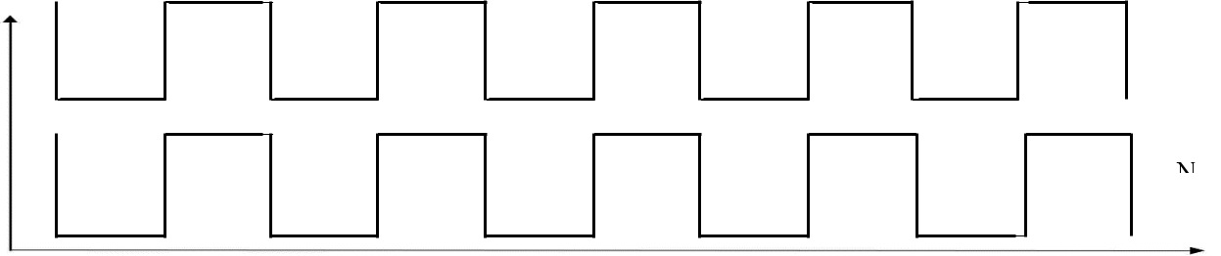

NA
O

i

O

Result: A clock using NAND Gate is designed and the output is verified

Viva questions:

- What are universal gates?

- Implement all basic gates using Universal gates.

Page 8 of 34

II BTech ECE - I Sem R18 Digital System Design Laboratory

10. Design a 4 – bit Adder / Subtractor

Aim: To design 4 bit adder /subtractor using digital IC

- A 4-bit binary parallel adder.

- A 4-bit binary parallel subtractor.

Apparatus:

- IC 7483 and IC 7486

- IC Trainer kit

- Patch Cords

Theory:

The Full adder can add single-digit binary numbers and carries. The largest sum that can be obtained using a full adder is 112. Parallel adders can add multiple-digit numbers. If full adders are placed in parallel, we can add two- or four-digit numbers or any other size desired. Figure below uses standard symbols to show a parallel adder capable of adding two, two-digit binary numbers. The addend would be on A inputs, and the augend on the B inputs. For this explanation we will assume there is no input to C0 (carry from a previous circuit).

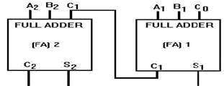

To add 102 (addend) and 012 (augend), the addend inputs will be 1 on A2 and 0 on A1. The augend inputs will be 0 on B2 and 1 on B1. Working from right to left, as we do in normal addition, let’s calculate the outputs of each full adder. With A1 at 0 and B1 at 1, the output of adder1 will be a sum (S1) of 1 with no carry (C1). Since A2 is 1 and B2 is 0, we have a sum (S2) of 1 with no carry (C2) from adder1. To determine the sum, read the outputs (C2, S2, and S1) from left to right. In this case, C2 = 0, S2 = 1, and S1 = 1. The sum, then, of 102 and 012 is 0112. To add four bits we require four full adders arranged in parallel. IC 7483 is a 4- bit parallel adder whose pin diagram is shown:

Page 9 of 34

II BTech ECE - I Sem R18 Digital System Design Laboratory

 | MSB |  |  |  | LSB
 |  |  |  |  | Cin
INPUTS |  | A3 | A2 | A1 | A0
 |  | B3 | B2 | B1 | B0
OUTPUT | Cout | S3 | S2 | S1 | S0

Pin diagram:

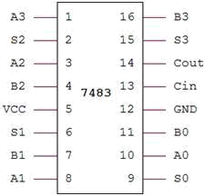

i) 4-Bit Binary Adder

An Example: 7+2=11 (1001)

7 is realized at A3 A2 A1 A0 = 0111 2 is realized at B3 B2 B1 B0 = 0010

Sum = 1001

Circuit diagram:

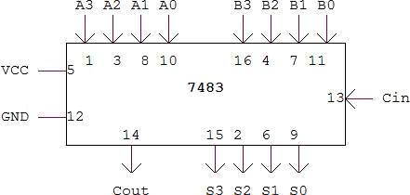

Page 10 of 34

II BTech ECE - I Sem R18 Digital System Design Laboratory

Procedure:

- Check all the components for their working.

- Insert the appropriate IC into the IC base.
- Make connections as shown in the circuit diagram.
- Apply augend and addend bits on A and B and cin=0.
- Verify the results and observe the outputs.

- 4-bit binary subtractor:

Subtraction is carried out by adding 2’s complement of the subtrahend.

Example: 8 – 3 = 5 (0101)

8 is realized at A3 A2 A1 A0 | = 1000
3 is realized at B3 B2 B1 B0 through X-OR gates = 0011

Output of X-OR gate is 1’s complement of 3 = 1100
2’s Complement can be obtained by adding Cin = 1

Therefore Cin =1

A3A2A1A0=1000

B3B2B1B0=1100

S3S2S1S0=0101

Cout = 1 (Ignored)

Circuit diagram:

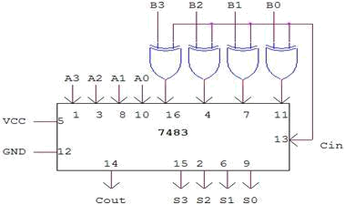

Procedure:

- Check all the components for their working.

- Insert the appropriate IC into the IC base.

- Make connections as shown in the circuit diagram.

- Apply Minuend and subtrahend bits on A and B and cin=1.

- Verify the results and observe the outputs.

Page 11 of 34

II BTech ECE - I Sem R18 Digital System Design Laboratory

Result: A 4-bit Adder and Subtractor are designed and the result is verified.

Viva questions:

- Compare Combinational and Sequential Logic.

- How many full adders are required to design an n-bit parallel adder?

- How to perform subtraction using 2’s complement method

Page 12 of 34

II BTech ECE - I Sem R18 Digital System Design Laboratory

11A. Design and Realization of a Synchronous Counter using Flip-Flops

Aim: To design a 4-bit synchronous up counter using D flip flops

Apparatus:

- IC 7474

- IC Trainer kit

- Patch Cords

Theory:

Counters: Flip flops can be connected together to perform counting operation. Such group of flip flops is a counter. Counters can be classified into two broad categories according to the way they are clocked: Asynchronous counters and Synchronous counters.

Asynchronous counter:

An asynchronous counter is the one in which the flip flops within the counter do not change states at exactly the same time because they do not have a common clock pulse. In fact, the first flip flop is clocked by the external clock pulse and then each successive flip flop is clocked by the output of the preceding flip flop

Synchronous counter:

In synchronous counters, the clock input is connected to all of the flip flops so that they are clocked simultaneously.

4-bit synchronous counter:

The 4-bit synchronous counter is implemented using positive edged D-Flip flop. The design is made using the truth table. It is clear that all the FF are triggered by the same clock pulse.

Pin diagram:

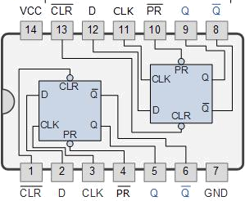

7474

Page 19 of 34

II BTech ECE - I Sem R18 Digital System Design Laboratory

Circuit diagram:

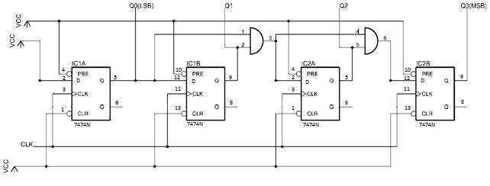

Procedure:

- Make the Connections as per the circuit diagram

- Switch on the power supply.

- Apply clock pulses and note the outputs after each clock pulse.

Truth table:

CLOCK | Q3 | Q2 | Q1 | Q0
PULSE
Initially | 0 | 0 | 0 | 0
1 | 0 | 0 | 0 | 1
2 | 0 | 0 | 1 | 0
3 | 0 | 0 | 1 | 1
4 | 0 | 1 | 0 | 0
5 | 0 | 1 | 0 | 1
6 | 0 | 1 | 1 | 0
7 | 0 | 1 | 1 | 1
8 | 1 | 0 | 0 | 0
9 | 1 | 0 | 0 | 1

Page 20 of 34

II BTech ECE - I Sem |  |  | R18 | Digital System Design Laboratory
 | 10 | 1 | 0 | 1 | 0
 | 11 | 1 | 0 | 1 | 1
 | 12 | 1 | 1 | 0 | 0
 | 13 | 1 | 1 | 0 | 1
 | 14 | 1 | 1 | 1 | 0
 | 15 | 1 | 1 | 1 | 1
 | 16(recycles) | 0 | 0 | 0 | 0

Expected Wave forms:

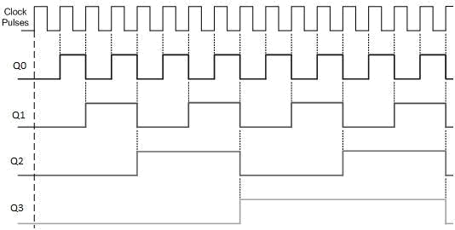

Result: A 4-bit synchronous counter were designed using D flip flop and their outputs were verified using the truth table.

Viva questions:

- What is flip flop? How does it differ from latch?

- What is counter?

- Bring out the difference between synchronous and asynchronous counter.

- Counter is a sequential circuit. Justify this statement.

- What is mod counter? What is the maximum mod counter that can be designed using 4 JK flip flop?

Page 21 of 34

II BTech ECE - I Sem R18 Digital System Design Laboratory

11 B. Design and Realization of Asynchronous Counter using Flip-Flops

Aim: To design a 4-bit asynchronous up counter using JK flip flops

Apparatus:

- IC 7476

- IC Trainer kit

- Patch Cords

Theory:

Counters: Flip flops can be connected together to perform counting operation. Such group of flip flops is a counter. Counters can be classified into two broad categories according to the way they are clocked. A counter in which each flip-flop is triggered by the output goes to previous flip-flop. As all the flip-flops do not change state simultaneously spike occur at the output. To avoid this, strobe pulse is required. Because of the propagation delay the operating speed of asynchronous counter is low. Asynchronous counter is easy and simple to construct 1. Asynchronous counters and 2. Synchronous counters

Asynchronous counter:

An asynchronous counter is the one in which the flip flops within the counter do not change states at exactly the same time because they do not have a common clock pulse. In fact, the first flip flop is clocked by the external clock pulse and then each successive flip flop is clocked by the output of the preceding flip flop. The 4-bit asynchronous counter is implemented using positive edged D-Flip flop. The design is made using the truth table. It is clear that all the FF are not triggered by the same clock pulse.

Synchronous counter:

In synchronous counters, the clock input is connected to all of the flip flops so that they are clocked simultaneously.

Pin diagram:

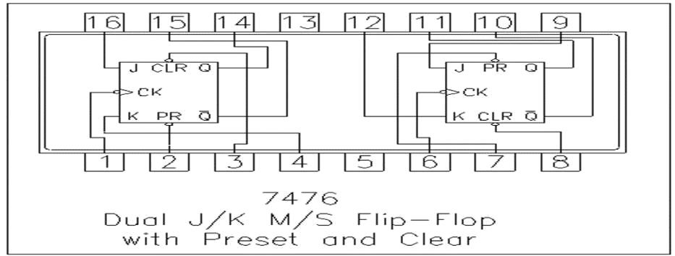

Page 22 of 34

II BTech ECE - I Sem R18 Digital System Design Laboratory

Circuit diagram:

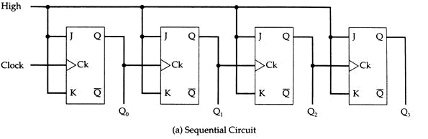

Procedure:

- Make the Connections as per the circuit diagram

- Switch on the power supply.

- Apply clock pulses and note the outputs after each clock pulse.

Truth table:

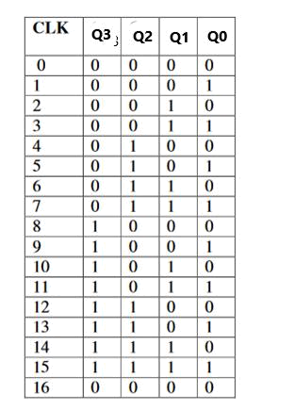

Page 23 of 34

II BTech ECE - I Sem R18 Digital System Design Laboratory

Expected Wave forms:

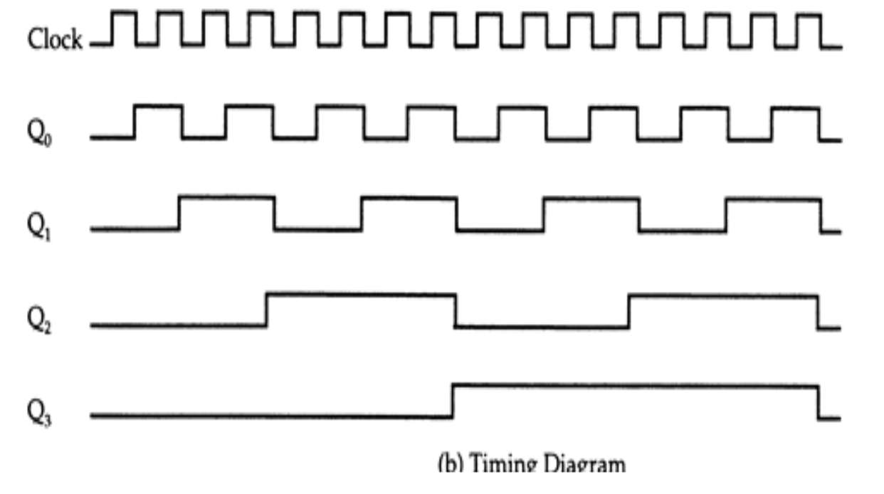

Result: A 4-bit asynchronous counter were designed using D flip flop and their outputs were verified using the truth table.

Viva questions:

- What is flip flop? How does it differ from latch?

- What is counter?

- Bring out the difference between synchronous and asynchronous counter.

- Counter is a sequential circuit. Justify this statement.

- What is mod counter? What is the maximum mod counter that can be designed using 4 JK flip flop?

Page 24 of 34

II BTech ECE - I Sem R18 Digital System Design Laboratory

13. 8X1 Multiplexer using 2X1 Multiplexer

Aim: Design a 8x1 multiplexer using 2X1 multiplexer.

Apparatus:

- Patch Cords
- IC 74LS157 (2X1 Mux) - 7 No.

Theory:

Multiplexers are very useful components in digital systems. They transfer a large number of information units over a smaller number of channels, (usually one channel) under the control of selection signals. Multiplexer means many to one. A multiplexer is a circuit with many inputs but only one output. By using control signals (select lines) we can select any input to the output. Multiplexer is also called as data selector because the output bit depends on the input data bit that is selected.

The general multiplexer circuit has 2n input signals, n control/select signals and 1 output signal. 8 X 1 Multiplexer has 8 input signals and one output signal, three data control or select lines. These data control lines are nothing but 3-bit binary code on the data control signal inputs which will allow the data on the corresponding data input to pass through to the data output

Pin Diagram:

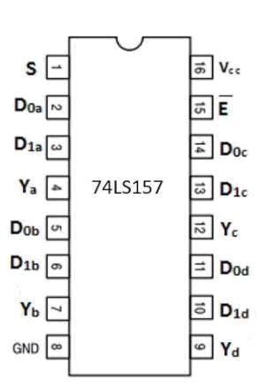

Page 25 of 34

II BTech ECE - I Sem R18 Digital System Design Laboratory

Block Diagram:
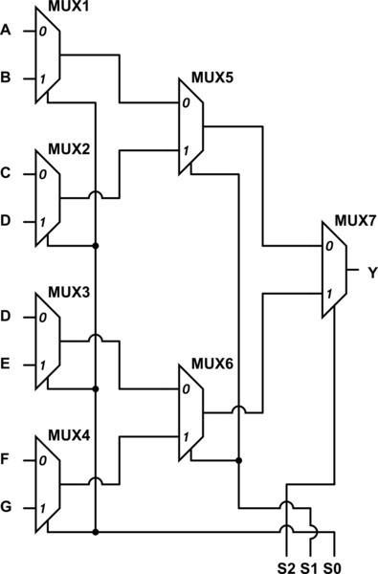

Circuit Diagram:

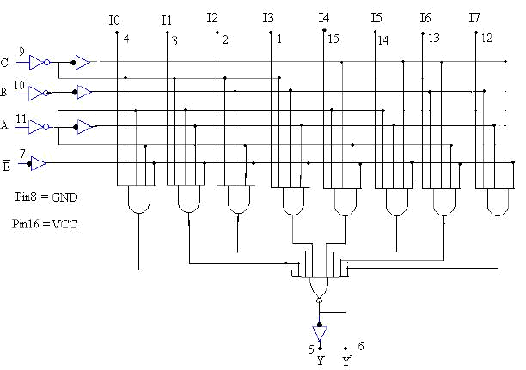

Page 26 of 34

II BTech ECE - I Sem R18 Digital System Design Laboratory

Truth Table:
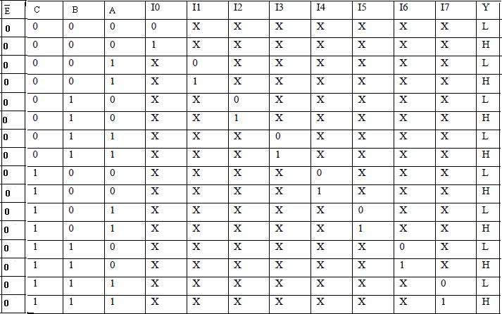

PROCEDURE:

- Connect the circuit as shown figure.
- Apply E=0 to enable the circuit.
- Apply A=0, B=0,C=0 to select the input ‘I0’ at the output for both ‘0’ and ‘1’.
- Repeat step for various values of A,B,C to select different inputs (I1 – I7) at output.
- Draw and verify the truth table.

Result: 8X1 Mux is designed using 2X1 Mux and the truth table is verified.

Viva Questions:

- What is a multiplexer?
- What is a de-multiplexer?
- What are the applications of multiplexer and de-multiplexer?
- Derive the Boolean expression for multiplexer and de-multiplexer.
- How do you realize a given function using multiplexer?
- What is the difference between multiplexer & demultiplexer?
- In 2n to 1 multiplexer how many selection lines are there?
- How to get higher order multiplexers?
- Implement an 8:1 mux using 4:1 mux?

Page 27 of 34

II BTech ECE - I Sem R18 Digital System Design Laboratory

14. 4-bit comparators

Aim: Design 4-bit comparators.

Apparatus:
- Patch Cords

- IC 74LS85 (4 Bit Comparator)-1 Nos.

Theory:

Magnitude Comparator is a logical circuit, which compares two signals A and B and generates three logical outputs, whether A > B, A =B, or A < B. IC 7485 is a high speed 4-bit Magnitude comparator, which compares two 4-bit words. The A = B Input must be held high for proper compare operation.

Pin diagram:

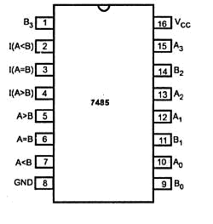

Block Diagram:

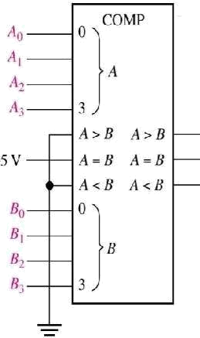

Page 28 of 34

II BTech ECE - I Sem R18 Digital System Design Laboratory

Circuit Diagram:

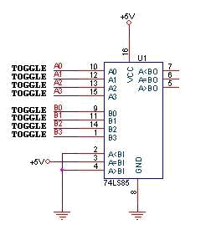

Procedure:
- Make the connection as per the above connection diagram.
- Switch On the power supply.
- Set the 8 bit inputs by the toggle Switches.
- Observed the Output on the LED.

Truth Table:

 | Input Condition | A<B | A=B | A>B
A0 A1 A2 A3 | >B0B1B2B3 | 0 | 0 | 1
A0A1A2A3=B0B1B2B3 |  | 0 | 1 | 0
A0 A1 A2 A3 | < B0 B1B2B3 | 1 | 0 | 0

Result: 4 bit comparators is designed, and the truth table is verified.

Viva Questions:

- What is a comparator?
- What are the applications of comparator?
- Derive the Boolean expressions of one bit comparator and two bit comparators.
- How do you realize a higher magnitude comparator using lower bit comparator
- Design a 2 bit comparator using a single Logic gates?
- Design an 8 bit comparator using a two numbers of IC 7485?

Page 29 of 34

